Advice for using Zoom  Privacy – this is probably the number one consideration. Find somewhere that you are confident you are not going to be overheard or disturbed. For some of you this will be your bedroom but for others you might need to consider somewhere like your car! You might put a Do Not Disturb sign on the door of the room you are in so others know not to come in. Also consider what is in the background of your video – remove any personal items  Position – position the camera so you can be seen from the shoulders up. Avoid the up the nostrils angle!  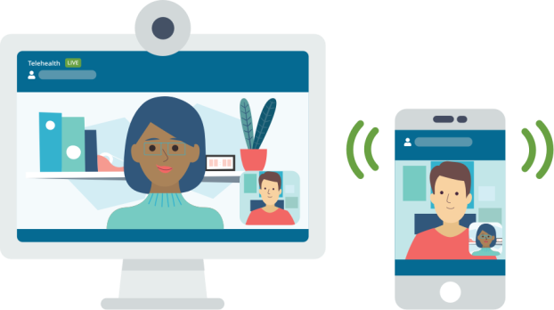  Comfort – sit somewhere comfortable and maybe have a drink of water/cup of tea or something to fidget with on hand  Headphones – if possible wear headphones so you can hear the clinician more clearly and no one can overhear the session  Laptop v mobile – We recommend using a desktop computer, laptop or tablet rather than a phone (if possible) as the screen is bigger, which means you can see your clinician and information being taught better. Also, phone notifications may be distracting. If you need to use a mobile phone, turn off notifications and place the mobile on a stable surface. | Please note that if you are using Zoom on a 3G/4G connection this may use up some of your data allowance and potentially increase your bill.  Zoom and Lucena Clinic Services/St John of God Services are not affiliated, sponsored, authorized, or otherwise associated by/with the Zoom group.  Important things to know...  By agreeing to attend a session on Zoom we are assuming you are consenting to take part in and accept any risks involved in this method of communication.  A parent/guardian must be present in the home when a child is attending an online appointment and be available to speak to Lucena clinician in case any urgent issue is disclosed in the appointment  If there is any query about possible child protection concerns, a face-to-face appointment will be arranged  Your clinician will not record sessions and we ask that you do not record the session either, as this would be a breach of Data Protection regulations.  If you do not want to attend a session via Zoom or have any concerns or questions please discuss this with the relevant clinician.  A Zoom session is like any other appointment, it is important that you notify the clinic in advance by phone if you are unable to attend. |   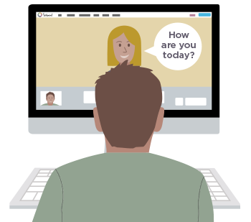  Information for Service Users  Attending a session, group or workshop via ‘Zoom’ Video Call
Why is this session happening via video call?  Lucena CAMHS is running this session* via video call to;  - Support access for clients who live in rural areas or with transport issues  - Eliminate travel time to be more convenient for families with busy schedules  - Allow us to maximize the number of clients who can attend a group or workshop (no room size constraints)  * “session” refers to an individual appointment for you and/or parent/ guardian, a group or a workshop  You are being offered a session through an online video software called Zoom.  What is Zoom and how do I download it?  Zoom is a free video conferencing app which you can download from: www.zoom.us onto your phone, tablet, laptop or desktop computer.    Is my session confidential?  Yes. Zoom has advanced security measures built into the software. However, we have chosen to make the call more secure, which means the clinician will password protect the call. This means only those with the password can access the call. | 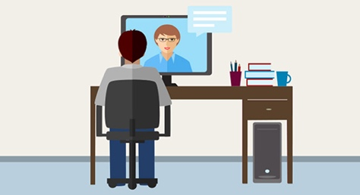  What happens if there are technical difficulties / issues during the session?  The clinician will try to resolve the issue with you as best they can. They may need to phone you to do this.  For more information about how to fix issues, please visit this website: https://support.zoom.us/hc/en-us/sections/200305593-Troubleshooting  How do I know when the session is on?  Your clinician will contact you with the time and dates of the session by phone or by letter.  Where will the clinician be during the Zoom session?  The clinician(s) will be in a private room so you can not been seen or heard by others. | 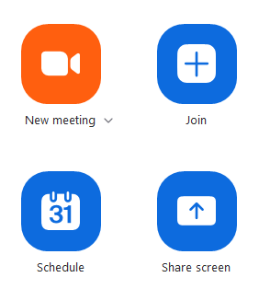  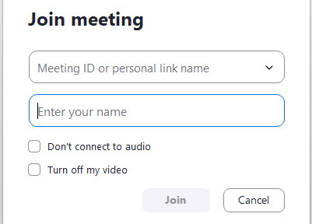  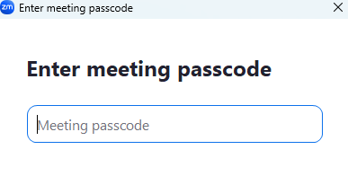  1) Fill in the Meeting ID  2) Fill in your name (i.e. the name you want to appear under your video)  3) Then click Join.  Fill in the password for the meeting.  Then the clinician will accept you into the meeting.  How do I access the call?  Prior to the workshop we will ring you with the Meeting ID and password.  To join the session, click Join

